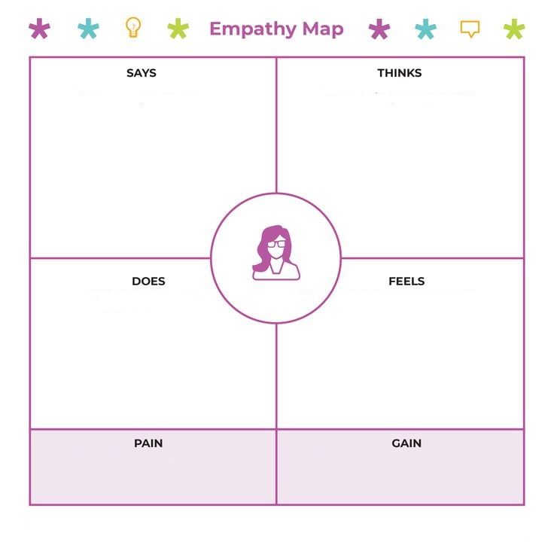

Queries related to bank is fast

Open new account for me User friendly

Branches of bank? Easy to use

Bank timings? Provide solutions to me

Online transfer

**CUSTOMER**

Logging in Secure

Type details Excited

Type password Curiosity

Access online services Efficient work

Requires internet. Has language barriers. Provides fast solutions.

Not a human-to-human interaction. Accessible anywhere.